Instructions to download app in NEXGO Conductor terminal
Contents
Step 1: Turn on the Device 2
Step 2: White Screen 2
Step 3: NEXGO Settings Screen 3
Step 4: Clear App 3
Step 5: Plug in 4
Step 6: Device Setting Screen 4
Step 7: Device Handshake Mode 5
Step 8: NEXGO TMU APP 5
Step 9: “NEXGO TMU v4.2.4” Screen 6
Step 10: Making Hanshake 6
Step 11: Connection 7
Step 12: Terminal app connected 7
Step 13: Load the Software 8
Step 14: Showing Your app 8
Step 15: Download Complete 9
Step 16: Download Confirmation. 9

Step 1: Turn on the Device
Press and hold the Power+1+F (buttons) together.
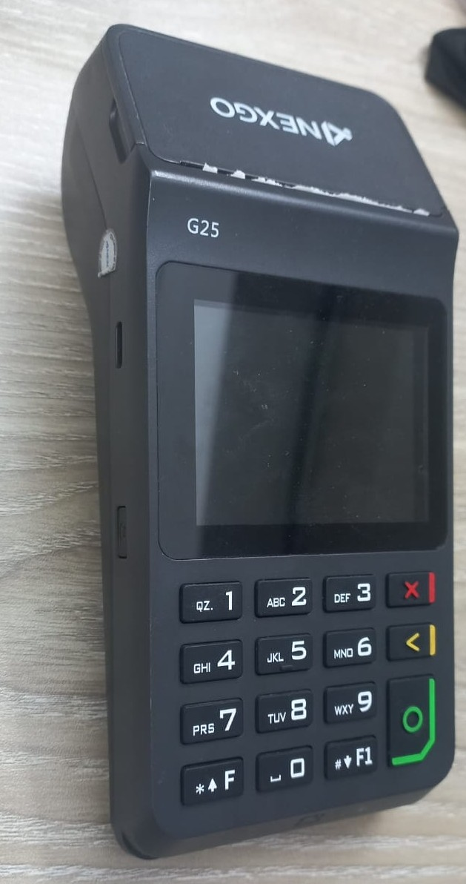

Step 2: White Screen
Keep holding the pressed buttons until a blue screen menu appears.
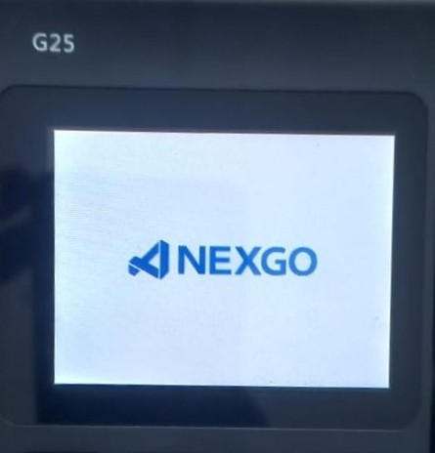

Step 3: NEXGO Settings Screen
We can See 4 options here. It’s the Settings screen.
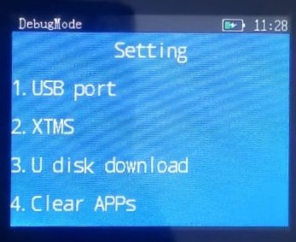

Step 4: Clear App
Select “4. Clear APPs” to clear the previous app with password: 83890345
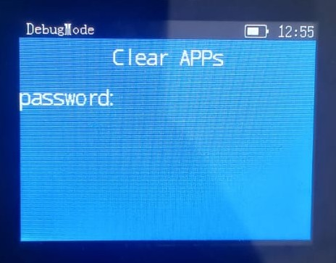

Step 5: Plug in
Plugin the data cable into the device Type-C port and proceed to computer.
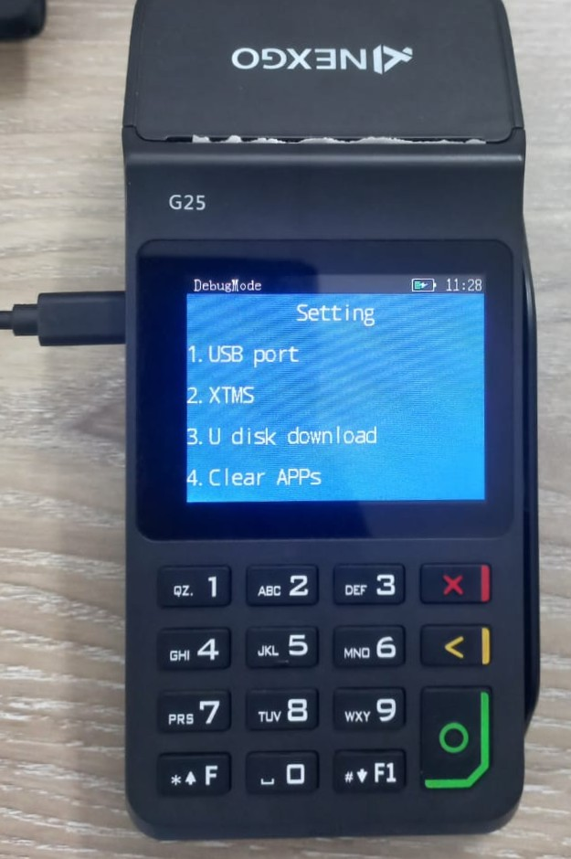

Step 6: Device Setting Screen
Press 1 for Option 1. USB port


Step 7: Device Handshake Mode
You will see a “Waiting handshake” message on the screen. Go back to TMU app on your computer.
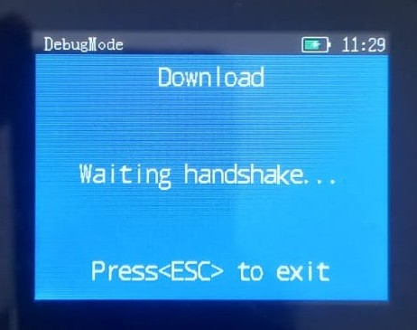

Step 8: NEXGO TMU APP
Open the “NEXGO TMU v4.2.4” App from start menu.
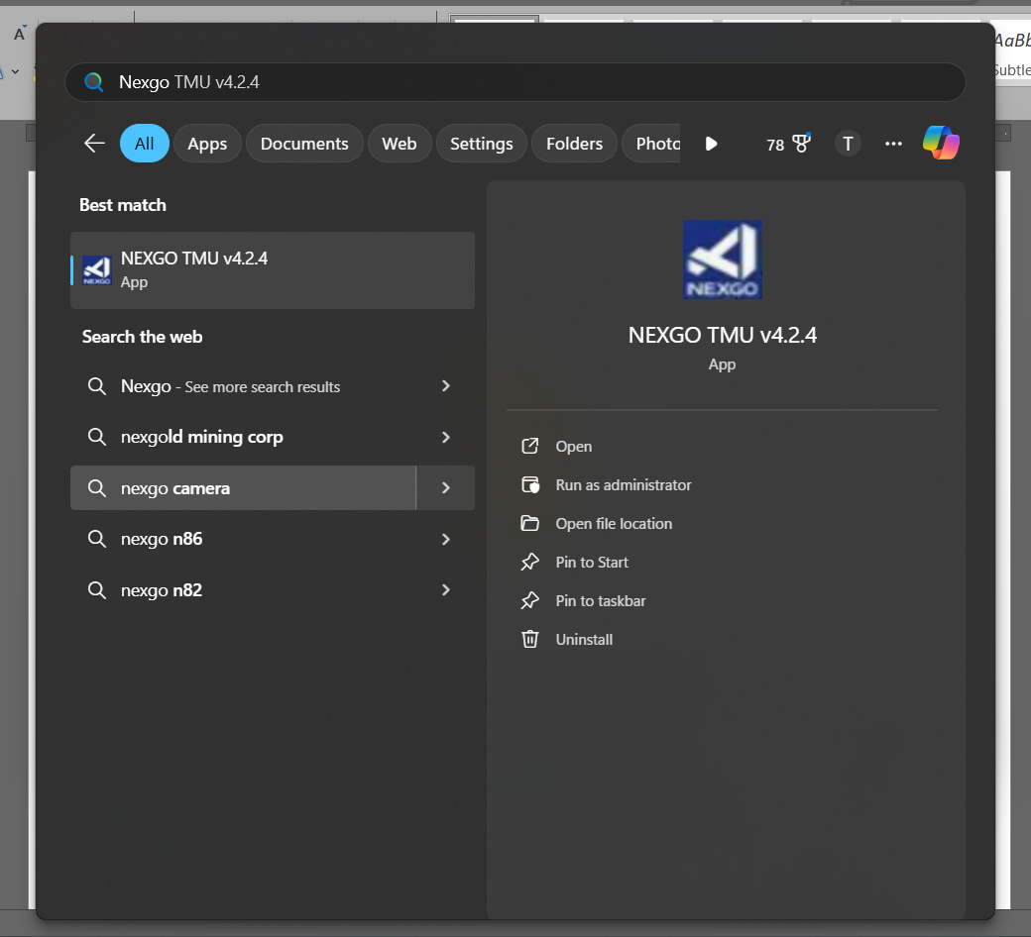

Step 9: “NEXGO TMU v4.2.4” Screen

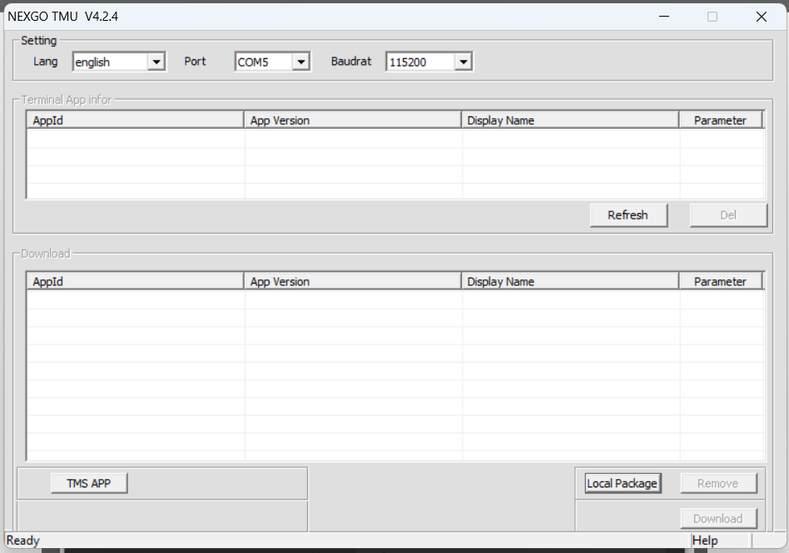

Step 10: Making Hanshake
Suffle the dropdown port numbers and press Refresh to communicate
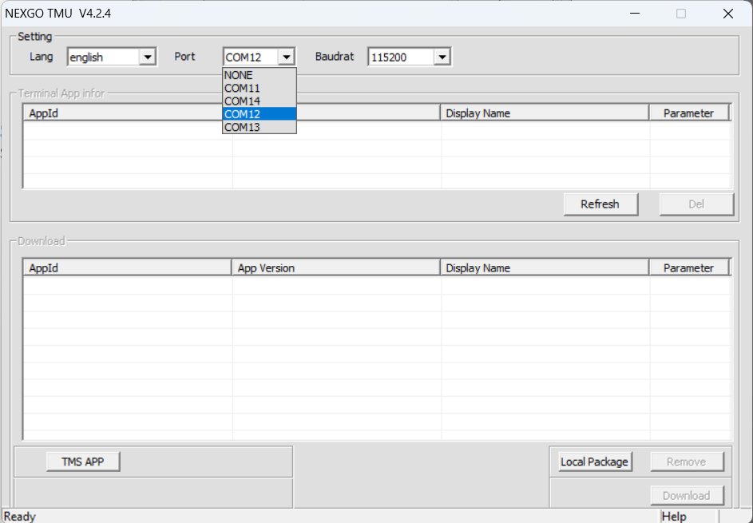

Step 11: Connection
You will see the app is trying to connect with your device every time you pick a port and refresh.
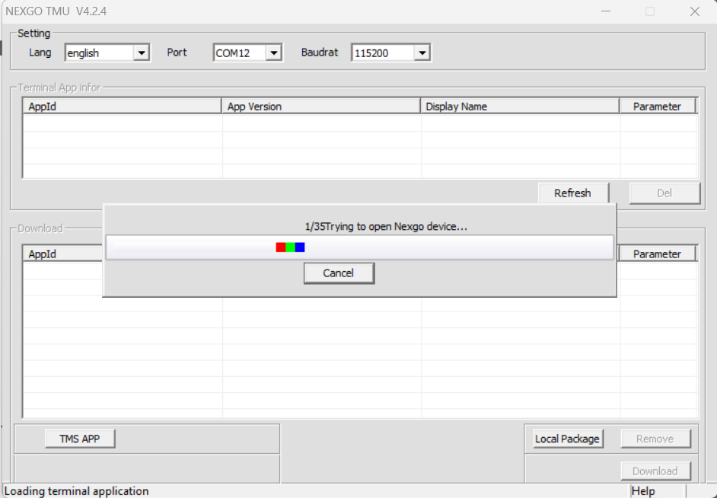
*NOTE: The connection takes 5 sec to establish, if its taking more the 10 sec change the port from TMU app dropdown and retry, you can change computer port too, then you have to restart the TMU app.

Step 12: Terminal app connected
If you can establish the connection, this “there are no app in terminal” popup window will be shown. As we cleared the app.
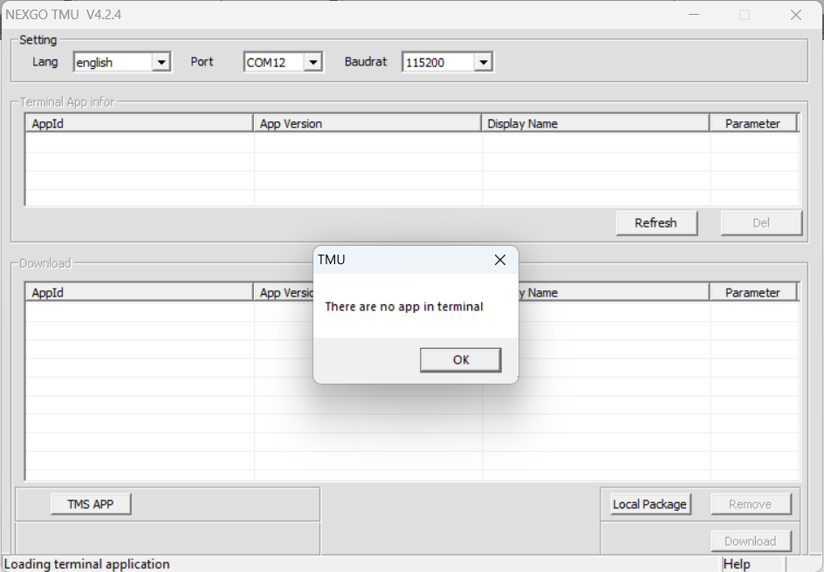

Step 13: Load the Software
Press “Local Package” button and select your software’s BF folder
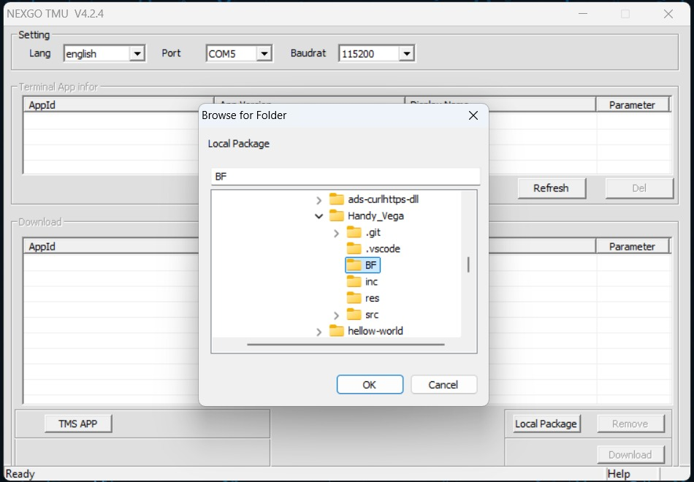

Step 14: Showing Your app
You will find your app under the Download Section, marked for download. Finaly, Press Download to download the app in the NEXGO Conductor Terminal
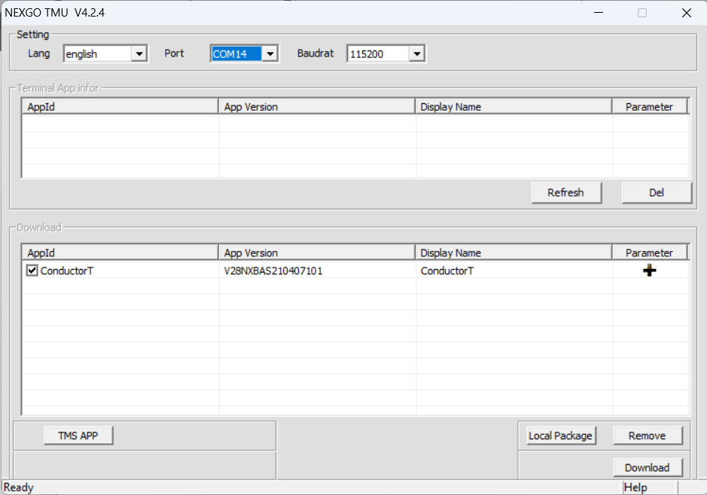

Step 15: Download Complete
A download finished popup window will appear over TMU app.
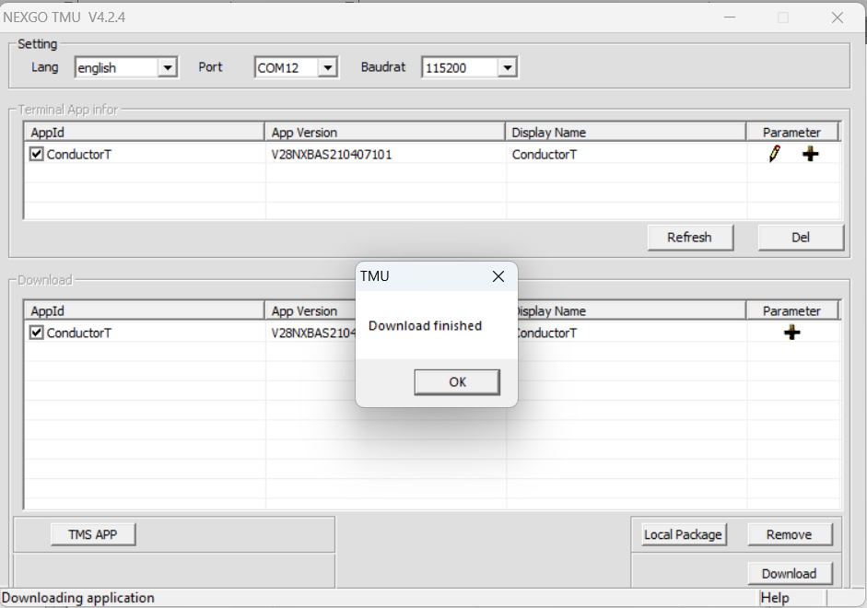

Step 16: Download Confirmation.
A download success message will appear in the Device. Then Restart the device and use.
